Automated Microbial Analysis Weekly Meeting Notes

* Group Members in Attendance
  + Bendt, Zachary
  + Bruslind, Jorian
  + Hall, Macklin
* Project Unknowns and Risks
  + Can a single Raspberry Pi be used to do image processing AND motor control?
  + Should we include a depression to catch the finished samples?
  + How can we ensure accurate motor movement?
  + Do we need to implement half-stepping in the motors? If so, will we still have enough torque?
* Tasks from This Week
  + Zach
    - Researched power supply problem with the Raspberry Pi.(30 min)
    - Researched OpenCV library. (2 hrs)
    - Researched Python coding integration with OpenCV (1 hr)
  + Jorian
    - Researched various limit switches for homing (1 hr)
    - Researched Industrial Delta Robot arm configurations (30 min)
    - Researched NEMA 17 stepper motors w/encoders (2 hrs)
  + Mack
    - Researched possible DC vacuum pumps (30 Min.)
    - Researched possible suction cups and fittings to attach to delta arm (45 Min.)
    - Researched solutions to drive the stepper motors (1.5 Hrs.)
* Group Meeting Topics
  + Group roles
  + Potential hardware
  + Enclosure shape/materials
  + Current vs. ideal system block diagram
  + Custom PCBs and where they fit into this project
  + Motor drivers
  + Software to drive the motors
  + Motor encoders/decoders
  + Power delivery quirks/issues
  + Workflow for the end-user
  + Output format
* New Items
  + N/A -- Welcome to the group!
* Tasks for Next Week
  + Zach
    - Continue refining OpenCV algorithms and testing (2hrs)
    - Research communication between microcontroller and RaspberryPi (1 hr)
    - Administrative paperwork (2 hrs)
  + Jorian
    - Bring IEC-C13 plug to next meeting in order to power auxiliary motor controls (5 min)
    - Begin mechanical design for robot linkages (3 Hrs)
      * Arms
      * Motor mounts
      * Frame mounting
    - Assemble full design in Inventor for simulations (1 Hrs)
    - Research torque requirements and solutions (2 Hrs)
  + Mack
    - Prepare microcontroller and driver board for power-on
      * Play around with software to control stepper motors (2 Hrs.)
      * Minor wiring to connect driver board and microcontroller (30 Min.)
    - Research motor encoders/decoders (1 Hr.)
  + Everyone
    - Look at other delta robots online for inspiration (15 Min.)
    - Finalize Group Name (15 Min.)
* Hours This Week

|  |  |  |  |
| --- | --- | --- | --- |
|  | Total Hours | Hours w/ Team | Hours Helping |
| Bendt, Zachary | 3.5 | 1 | 2 |
| Bruslind, Jorian | 3.5 | 1 | 2 |
| Hall, Macklin | 3.75 | 1 | 1 |

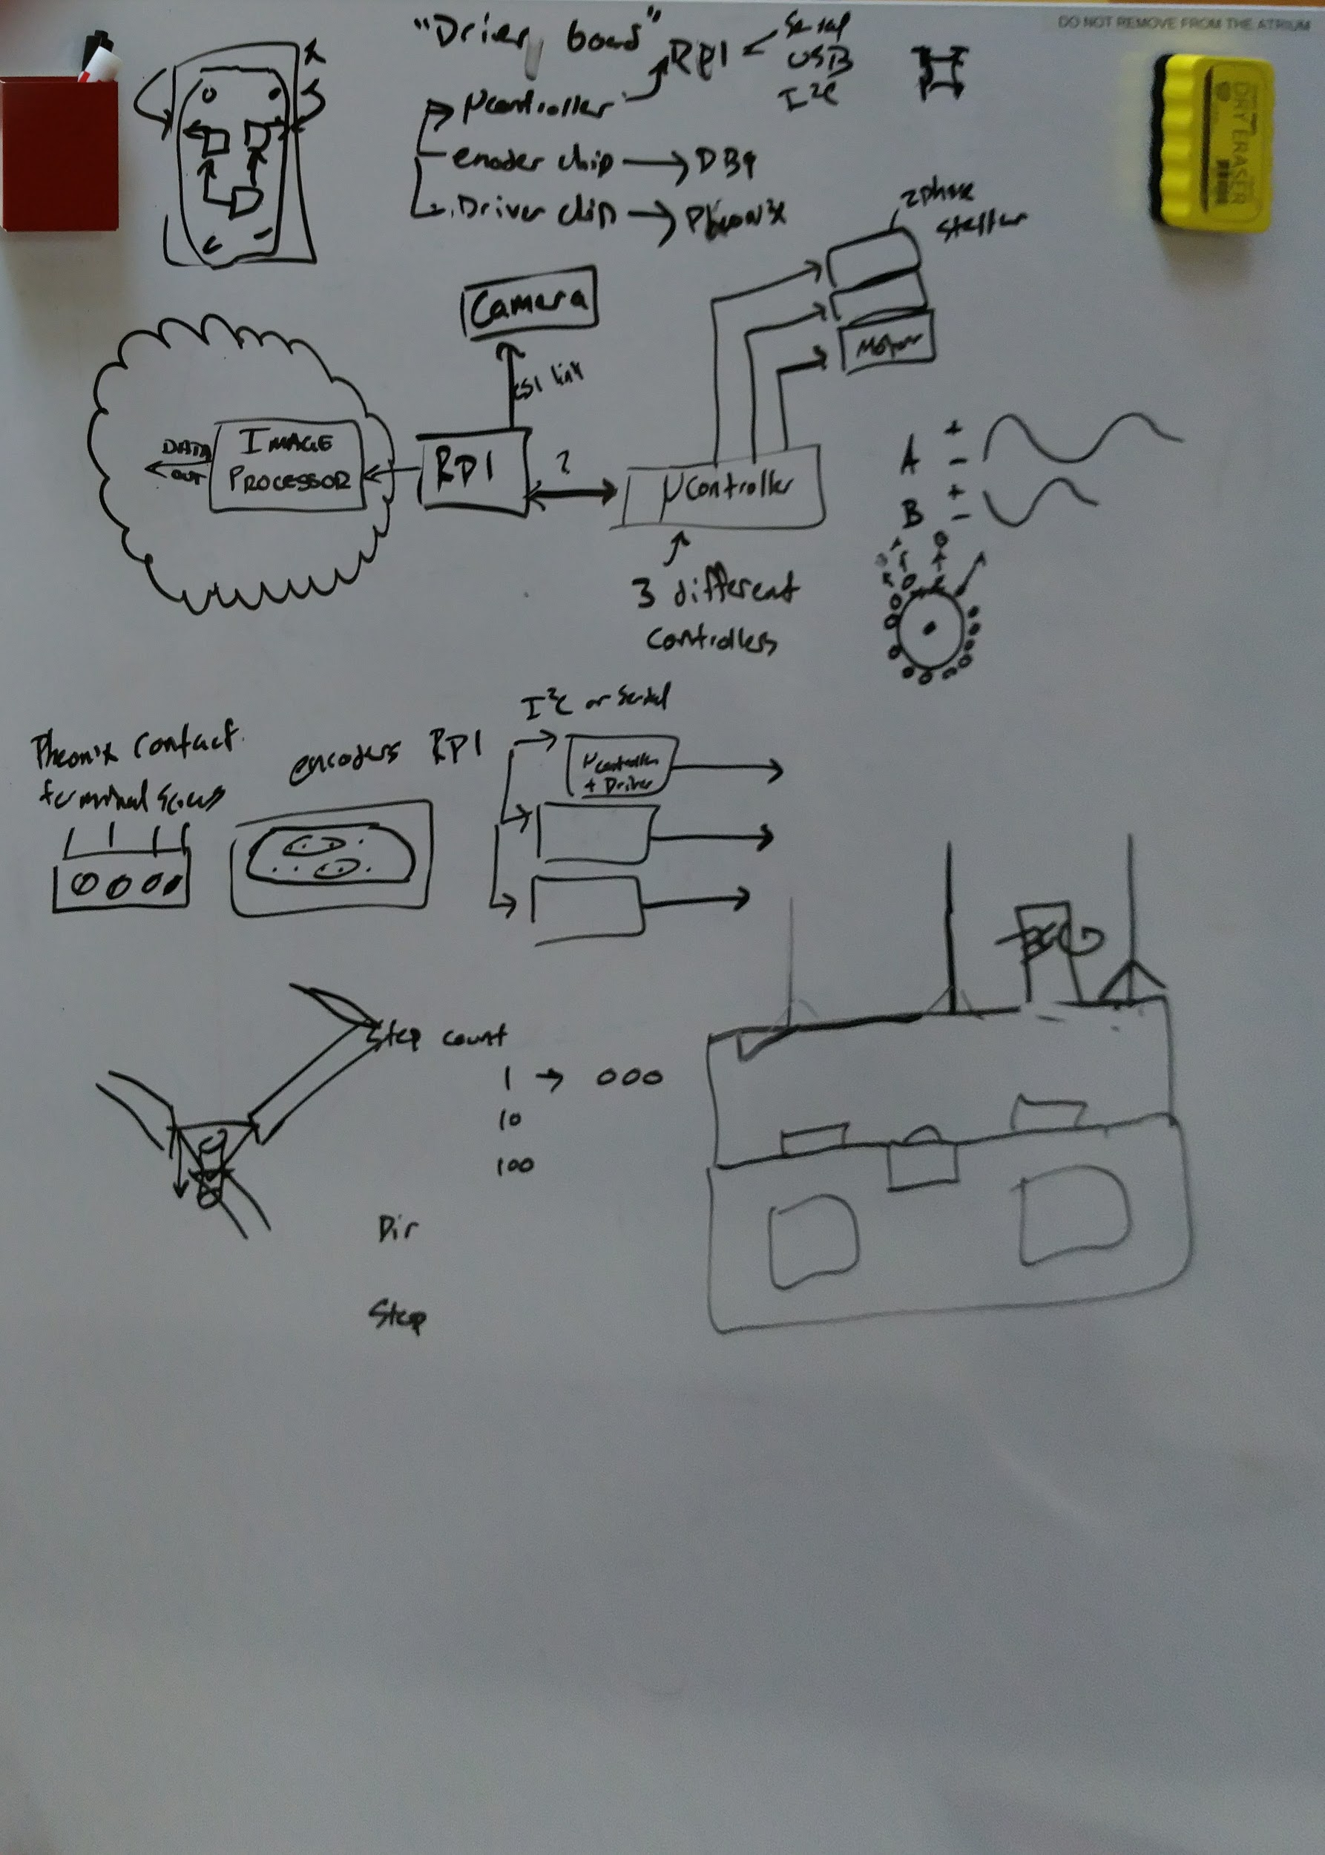

* Meeting Scribbles